Hungarian Review

18 May 2020

Gábor Turi

Ritual and Tradition – Attila Vidnyánszky’s Formative Years at the Csokonai Theatre of Debrecen
In 2013 the new general director of the National Theatre in Budapest stepped onto the bridge of the flagship of Hungary’s theatre scene as an ethnic Hungarian from outside the country’s present-day borders. The journey of Attila Vidnyánszky, born into a family of teachers in the Subcarpathian region, Ukraine, in 1964, led him from the Gyula Illyés Hungarian National Theatre in Beregszász (Berehove, Ukraine) to the Hungarian capital via Debrecen. His years spent as director of the Csokonai Theatre there between 2006 and 2013 were a deciding factor in his being chosen for the role. Although his character as a stage director had emerged in Beregszász, it was in Debrecen that the principles of his approach to theatre management crystallised. Taking stock of this period is the key to understanding his endeavours as head of the National Theatre in the capital.
IN AN ALLIANCE, ALONE
Director János Csányi and artistic director Attila Vidnyánszky won over the Fidesz–KDNP–MDF coalition heading the Debrecen City Council with an ambitious plan in 2006. The alliance between the two was initiated by the city’s leaders, who envisioned an executive director and artistic director working in tandem. Vidnyánszky was chosen on the strength of his work as a director, which revealed powerful talent and a new voice. As a theatre manager and founder of the Bárka Theatre in Budapest, Csányi had already had contacts with the city in 2004. He had helped draw up Debrecen’s application for European Capital of Culture status, including a plan for a new theatre with the working name of “Latinovits” (after a well-known Hungarian actor).
One of the objectives of the 250-page proposal entitled The Art of the Community was the creation of a regional network of theatres, the construction of a new theatre, an updating of the language of form used in theatre, the founding of a stage academy and the holding of an international festival. In the introduction, Vidnyánszky summarised his philosophy and approach to theatre as follows:
The theatre, as one of the most ancient forms of expression of human culture, is founded on ritual and tradition [...]. The most influential innovators of 20th-century European theatre (including Craig, Meyerhold, Artaud, Grotowski, Brook, Kantor, Mnouchkine, Wilson, Vasiliev, Suzuki, to name just a few) believed that in the modern age we have to move beyond the entertainment and psychological realism of popular theatre, and create a new sacral space for the coming age [...]. There is an old, very human world that is rich in values and close to our hearts yet also archaic and perhaps unviable, which is opposed by a far colder, sometimes cynical and occasionally inhumane, but extremely vital new order, and the two clash irreconcilably [...]. In this tragic situation, the only possible answer to “NO”, to the theatre of denial, is a positive message, the theatre of “YES” [...].¹
Csányi defined the mission of the Csokonai Theatre within the framework of a restructuring of the Hungarian theatre scene: “In Hungary – like in Germany or Sweden – in the vast majority of cases the conditions for operation as a repertory theatre must be retained [...]. It is essential to separate the systems of theatre funding of Budapest and the rest of the country. Deliberate efforts must be made to create a counterpoint to the unipolar theatre scene of Budapest – through the development of regional theatre bases – in order to establish healthy competition and a multipolar scene that offers genuine alternatives.”²

PLANS AND REALITY

The two leaders threw themselves into making their plans a reality. Vidnyánszky focused on compiling the schedule of events and building up the company, as well as on his own directing, while Csányi laid the foundations for the other pillars of the concept. The stalling of the construction of the “Latinovits” narrowed their options: instead of a new, state-of-the-art playhouse, they had to make do with the run-down Csokonai, a former cinema converted into the Víg Chamber Theatre and a studio that had previously served as a rehearsal room.
The plan to establish a stage academy turned out to be unworkable, although the two colleagues had different ideas about how it should have been achieved anyway. Csányi favoured launching comprehensive theatre training embedded in the curriculum of Debrecen University, while Vidnyánszky believed in the studio-style training of artists in small groups. The plans to hold a much-needed international theatre festival in Hungary also proved to be an illusory desire, although with the addition of the Latinovits Theatre the local infrastructure, exceptionally well-equipped by provincial standards, would have been ideal for hosting such an event.
The 2006/2007 season, planned by Vidnyánszky, certainly kicked off in a new spirit and with a highly idiosyncratic programme that included a guest opera director from abroad, the Jel (Sign) Festival paying homage to the world-famous choreographer József Nagy and a performance of Vidnyánszky’s calling card, Liberté ’56, which commemorates the 1956 Revolution.
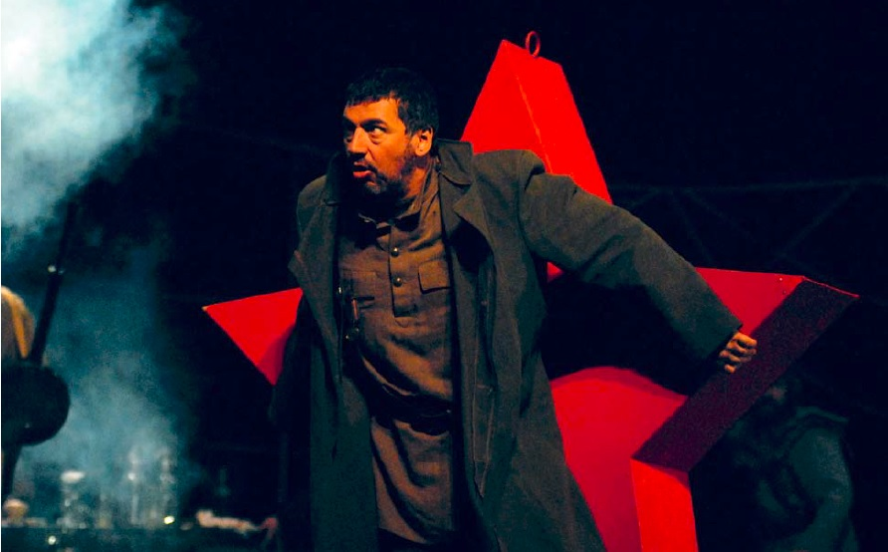
Liberté ’56. Directed by Attila Vidnyánszky. Csokonai Theatre, Debrecen. Photo: András Máthé
After this, however, the momentum stalled as the promising collaboration between the two professionals was ended by Csányi’s dismissal on 31 March 2007. The managing director’s commitments spanning several years had come into conflict with the local council’s annual planning procedures. Vidnyánszky ran the institution for two years as acting director. Then, as the sole applicant, the City Council appointed him director with effect from 1 March 2009.
Although he was born to be an artist and not a manager, the job soon turned out to be far from onerous: now he had more freedom to put his ideas into practice. He approached the running of the theatre not as a manager who understands and defines every process down to the tiniest detail, but by taking a long-term view, setting a course and building up an image. He was greatly assisted in his new role by the outstanding team of professionals that had formed around him in the course of earlier collaborations.
Vidnyánszky’s world view and character were shaped by his ethnicity, his Ukrainian and Russian theatre training, a growing sense of his Hungarian identity, his family values and Christian beliefs. He was born in a Hungarian neighbourhood in Subcarpathia, Ukraine, and studied in Russian to earn his degree in theatre in Kiev, and it was in this context that he originally envisioned his future career. The establishment of the Gyula Illyés Hungarian National Theatre in Beregszász (Berehove) had not been his idea, but once he became involved, it became (also) his project. This experience gradually awakened in him a sense of his ethnic identity, the need to participate in Hungarian rather than/as well as Ukrainian–Russian culture. This orientation was also reflected in his choice of programme for the theatre in Beregszász, but only truly started to take shape when the institution was integrated into the Hungarian theatre circuit. This was also what brought him closer to political movements that were vocal in their representation of national issues.
It is no coincidence that several of his immediate colleagues also hailed from outside of Hungary’s administrative borders. Judit Nagy, the young and assertive chief financial officer was from Nagyvárad (Oradea, Romania), and the artistic general secretary Edit Kulcsár, a qualified dramaturge, from Szatmárnémeti (Satu Mare, Romania). Nina Király, who took care of foreign relations and has also earned recognition both in Poland and Russia, was formerly director of the National Museum and Institute of Theatre, while the translator/dramaturge András Kozma had studied and worked in Moscow at Anatoly Vasiliev’s School of the Dramatic Arts. Alongside them, the director Attila Mispál contributed his experience in film-making, dramaturge and director Zsolt Szász his knowledge of ancient Hungarian traditions and puppetry, dramaturge and translator Zsófia Rideg contributed her knowledge of the French language and culture, and dancer and choreographer Péter Gemza his experience gained at József Nagy’s Jel Theatre. (With one or two exceptions, this is also the team he works with at the National Theatre in Budapest.)
Accompanying Vidnyánszky to Debrecen (and later to Budapest) was his closest artistic collaborator, the Ukrainian Oleksandr Bilozub, designer of the sets and costumes for 14 productions in Debrecen, who made the director’s visions into reality through his inventive use of visual effects, colours and materials.

PLAYERS, SOULMATES
One of Debrecen’s aims in hiring Vidnyánszky was to offer a helping hand to the Hungarian theatre in Beregszász, which was operating under deplorable conditions. The idea was a success, as productions from Beregszász featured regularly in the season ticket programme. The director also signed up five of its actors – including the exceptionally talented couple Zsolt Trill and Nelli Szűcs – in Debrecen (and later at the National Theatre). In the first season, they were joined by eight new graduates from the Academy of Drama and Film in Budapest. The third main group of players within the company consisted of local actors who had settled in Debrecen. The company was also joined by such big names from theatre and music as the actors Anna Ráckevei, Lajos Ottó Horváth, György Cserhalmi and the rock legend László Földes, better known as Hobo.
Cultivating a harmonious relationship between these company members from different theatres – and countries – with different backgrounds, attitudes and acting approaches was no easy task. Vidnyánszky thinks in terms of the whole company, treating his colleagues as family, and does not like discussing their internal affairs in public; but he later admitted that “[t]he process of building the company was not completed; it was interrupted”.³ He let some members go, and several of the younger actors found opportunities at theatres in the capital more attractive, and they moved on.
Vidnyánszky’s approach to theatre is centred on the actor, but directors collaborating either as members of the troupe or as guest artists nevertheless left a deeper mark on the legacy of his time in Debrecen. This was the manifestation of his declared policy of openness and an international outlook. There is barely any other Hungarian theatre that has employed as many artists and directors from abroad as the Csokonai in Debrecen between 2006 and 2013. Ten foreign directors worked on 23 productions at Vidnyánszky’s personal invitation, including such prominent figures from the European theatre scene as the Romanian Silviu Purcărete, the Russian Viktor Ryzhakov and Sergey Masloboyschikov, the Polish Andrzej Bubień, the Ukrainian Vlad Troitskyi, the French Nadine Duffaut and Valère Novarina, the British Tim Carroll, the Italian Marco Spada and the American Paul Zimet. So many different habits, perspectives, approaches and methods, which gave not only the company but also the audience the opportunity to look outwards and come face-to-face with a different way of thinking. The fact that so many of them regularly returned to the Csokonai’s workshops (and later to the National Theatre) is a testament to the inspiring creative atmosphere. As Novarina recalled: “I’d never had a company like this [...] which performed in such unison, to such a high standard [...]. Their strength lies in how they manage to pull of something that is circuslike, fairground, Meyerhold-esque and athletic, while all the time building on human truths [...].”⁴
Vidnyánszky did not want to invite directors who made theatre like his own. Examples of this were Ryzhakov, who believed in the primacy of dialogue, or the “word painter” Novarina, whose directing of his play Imaginary Operetta introduced both the troupe and the audience to an abstract mode of performance hitherto absent from the Hungarian theatre scene. The relationship was based mainly on a spiritual kinship. Although sometimes controversial, the presence of the foreigners had a motivating effect on the company, inspiring a series of outstanding performances. The guest directors found it easier to strike up a rapport with the seasoned team players from Beregszász than with the Hungarian actors who prioritised the role of the individual. The success of these collaborations is demonstrated by the fact that seven productions from the cycle were invited to the National Theatre Festival in Pécs. The selection committee chose three plays directed by Vidnyánszky (Liberté ’56, Gentlemen’s Binge, Fabulous Men with Wings), and four by guest directors from abroad (Bubień: Oblom-off, Ryzhakov: The Hairdresser, Purcărete: Scapin, the Schemer, Troitskyi: The Government Inspector). The Hairdresser earned the title of best performance, while Fabulous Men with Wings won an award for its unique visual spectacle and complex use of theatrical tools. The high standard of acting during this cycle was reflected in the prizes awarded by the actors’ equity association MASZK: Zsolt Trill (Oblom-off) came home from the festival with the award for best male actor, Nelli Szűcs (The Hairdresser) with the prize for best female, and Tibor Mészáros (Scapin) received the prize for the best supporting actor.
Besides the international opening and shared views on the theatre, the high proportion of guest directors from abroad may also have been motivated by the shortage of suitably like-minded Hungarian directors. Twenty-one Hungarian directors worked at the Csokonai during the seven years, but few were returning guests. With 26 premieres the director himself topped the list, which shows that Vidnyánszky set out to shape the institution’s image primarily through his own works.

FROM ZSÁMBÉK TO PARIS

An essential part of the theatre-building in Debrecen was the chain of co-productions through which Vidnyánszky expanded the theatre’s scope and network of relationship, both geographically and financially. The closest links were naturally forged with the theatre in Beregszász, but several other institutions, venues and festivals also became part of the network, such as Gyula Castle Theatre, the Bartók+ International Opera Festival in Miskolc, the Szeged Open-Air Festival, the National Theatre of Szeged, Szentendre Cultural Centre, the Budapest Spring Festival, the Budapest Chamber Theatre, the Opéra Théâtre d’Avignon, the Opéra de Reims and the Hungarian State Opera House. The co-productions, which included operatic works, were mutually beneficial not only because of the cost-sharing, but also because they created an opportunity for the Debrecen company to perform and test their abilities in front of different audiences, and make use of the experience thus gained. Most of the guest appearances were given during the summer season and the most common venues were the Gyula Castle Theatre, the Theatre and Art Base in Zsámbék, and the Open-Air Stage on Budapest’s Margaret Island.
Performing abroad is a particularly important experience for provincial theatre companies, for whom such opportunities are few and far between. Here, too, Vidnyánszky capitalised on his reputation garnered through the festival performances of the Beregszász company. Invitations to give festival and guest performances arrived thick and fast: Liberté ’56 (Lendava), The Storm (Torun, Pilsen, Kiev, Beregszász), Lucia di Lammermoor (Nowy Sacz), Bánk Bán (Bytom), Dundo Maroje (Dubrovnik, Split, Lendava), I, Gáspár Károli (Carei), Imaginary Operetta (Paris, Cluj-Napoca), The Hairdresser (Beregszász, Yaroslavl, Minsk, Sfântu Gheorghe, Satu Mare), As You Like It (Gdańsk, Neuss), Fabulous Men with Wings (Yaroslavl, Bucharest). Especially prominent among the guest appearances were the five performances of Imaginary Operetta at the Paris Odéon, which brought this hitherto unknown eastern Hungarian company to the attention of the French capital’s theatre-going elite. This production, which went unnoticed by the Hungarian media, represented a major achievement for Hungarian theatre in France. There could be no greater accolade than this to crown the ever-deepening relationship between the Debrecen company and the remarkable French contemporary theatricians, writer and director Valère Novarina and composer Christian Paccoud.
The Csokonai Theatre company not only took part in events in Hungary and abroad, but also hosted its own festivals. In 2006, the Jel Festival shone a spotlight on the artistry of József Nagy, while in 2009 the works of French contemporary choreographers were shown. In keeping with its mission, the theatre gave a home to the International Nativity Play Festival, which had been deprived of its former venue in the capital. The DESZKA Festival organised jointly with the Drama Writers’ Round Table since 2007 is the most important forum for contemporary Hungarian drama, growing to become an intellectual workshop for writers, directors and actors alike. This meeting, showcasing around twenty guest performances every year, has become an important event in the city’s theatrical calendar.

THE DEBRECEN MODEL

The implementation of a new theatrical concept, with more exacting standards of quality and a modern language of form, was never expected to go without a hitch. However, it was hardly possible to foresee that besides the inevitable initial resistance from a part of the audience, it would also be obstructed by changes in the external operating environment. Over the years, the municipality reduced the theatre’s funding by some 200 million HUF (while 15 premieres were held per season in the peak years, this dropped to 11–13 after the cuts).
In spite of this, Vidnyánszky successfully marked out a strategy and established a theatre management concept that started to be referred to as the “Debrecen model” in professional circles. In his foreword to The Poetic Theatre, an album summarising the seven-year period, he defined the essence of this as a triad of tradition, modernity and internationality. “In the spirit of anthropological thought – after Grotowski and Eugenio Barba – I also want to stress the need for us to turn towards our own values. I am researching the vocabulary of gestures that is characteristic of us and us alone, a language of theatre that combines music and movement, as well as incorporating folk culture”, he added.⁵
These efforts were reflected in the repertoire, with a two-to-three ratio of Hungarian and international literary works among the productions. The Hungarian classics were represented by the works of Szigligeti, Molnár, Móricz, Krúdy, Vörösmarty, Márai and Madách, and plays inspired by them, while the modern writers included such names as Magda Szabó, Géza Szőcs, Csaba Kiss, Szilárd Borbély, Miklós Tóth-Máthé, István Kocsis, Miklós Hubay and János Pilinszky. The list of classics from world literature included works by Plautus, Shakespeare, Rostand, Držic, Cervantes, Gogol, Molière, Feydeau and Ostrovsky; but modern drama also had an emphatic presence through the play of Maddow, Ugarov, Novarina, Medvedev, Albee and Vyrypaev. Just like the line-up of invited foreign guest directors, the choice of plays also showed a distinct Slavic influence.
Having made Debrecen his home, Vidnyánszky made a point of also putting on plays associated with the city (Móricz–Háy: Be Faithful unto Death, Magda Szabó: The Wednesday of the Cats, Szilárd Borbély: Dea Debrecen), and encouraged the holding of workshops with local writers and creative communities. The relationship with Szilárd Borbély proved to be especially fruitful, leading to three noteworthy productions.
Sometimes naming the writers can make life more difficult for the chronicler because owing to the nature of modern theatre, directors often treat the script of the play merely as a starting point. Naturally, variants that are more or less faithful to the original have also been staged, but also a good many other performances are qualified with the phrases “inspired by...”, “based on...” or “with dialogue from...”. Not even Shakespeare was exempt: snippets of the Bard’s other works found their way into performances of The Tempest.

TOTAL THEATRE

Creative workshops or a production line? This was the choice faced by the artistic director of the Beregszász company, a community of friends who breathed as one and gestated their productions for “the full nine months”, when in 2005 Vidnyánszky had to decide whether to continue as he was, or relocate to the brick-built theatre in Hungary with its better opportunities. After the years spent in Beregszász under deplorable conditions but in an unfettered creative atmosphere, it took a lot of self-discipline to adapt to the constraints resulting from the procedures of the repertory theatre. Granted, his view of theatre performance as a constant creative process was also a factor in this, because in his approach the rehearsals do not end on the night of the premiere; the final form of the production takes shape on the stage, in front of the audiences, over the course of several performances. This practice runs counter to the conventions of popular theatre, which elevates the premiere to the status of a social event, the birth of the production.
And this brings us to the question of what kind of theatrical event came to define the theatre in Debrecen. The method of directing that shifted the dialogue in the direction of a complex stage performance was reflected most characteristically in Vidnyánszky’s own works. He said of this: “I’ve used the term ‘fragmented dramaturgy’ for a long time, by which I mean that I don’t use closed dramatic structures; or if I do work with these, I pick the dialogue apart. I’m not interested in causal relationships, because that’s not how people work either. I’m far more interested in the whole, like the world, in which everything is ‘simultaneously’ present.”⁶
Vidnyánszky’s theatre, highly acclaimed by foreign theatre professionals and critics alike, is not a reproduction of reality. In his performances, regardless of the themes, everyday life, social situations and current political events are referred to obliquely if at all. Rather, he is concerned with the big, eternal questions of human existence; and the events on stage gain their meaning in a metaphysical dimension. Most of his plays can be placed at coordinates on the horizontal (human) and vertical (transcendent, divine) planes. Productions that emblematically bear his hallmark, such as Liberté ’56, Funeral Pomp, Fabulous Men with Wings or The Tragedy of Man were staged with a “total theatre” approach in which speech, noise, movement, gesture, dance, spectacle, matter, and music as an organising force, are simultaneously present in equal measure. The concurrent events on the stage, the verbal and audio-visual impulses that divide the attention, shift the act of observation from the conceptual to the domain of the senses, are seriously challenging for an audience raised on realist, psychologising, dialogue-centred theatre and linear plots.
This was reflected in the development of audience figures in Debrecen. The artistic theatrical endeavours and linguistically complex performances, demanding intense concentration, resulted in a greater change to the composition of the audience than is usual following a change of director. Around two thirds of the season ticket holders, who were seeking a night out with some light entertainment stopped attending and their places were taken by a receptive, values-oriented audience base consisting primarily of young intellectuals.

OPERA ON HIGH

While prose dominated, the cycle was also characterised by the staging of opera and musical productions. A meeting between Vidnyánszky and Balázs Kocsár, the newly appointed conductor and musical director (2006–2011) of the Debrecen Philharmonic Orchestra, resulted in a mutually inspiring artistic collaboration, an ambitious programme and high-quality operatic performances. But it started with a painful amputation: at the end of the first year, the singers in the opera section, which had a history of more than half a century, as well as the dancing troupe established in previous years, ceased to be members of the company. The artists later were offered roles as guest performers. Neither music nor movement were banished from the life of the theatre, however, and Vidnyánszky’s attraction to the musical genres was well known (in 2004 he was chief artistic director of the Opera House). The decision was made for reasons of quality: in the provincial parts of the country, mainly due to a lack of financial resources, there is no way of maintaining an opera section and ballet section of the quality needed to meet the high expectations of today’s audiences. This is why they decided to cover these two genres in a different structure, through collaboration with guest artists.
This approach was vindicated by the composition of the 94 productions put on during the seven seasons: music (opera, operetta, musical, vocal and instrumental numbers) was a defining or prominent feature of 34 premieres. Opera was at the forefront of these endeavours: a total of 18 works were staged during the seven seasons, which is an outstanding figure for the provinces of Hungary. These included popular productions and rediscovered musical plays performed in their original versions, but there were also original new productions, and even a world premiere. The number one star was Puccini, with five operas in the programme, while Verdi, Rossini and Erkel had two each. The sometimes traditional, sometimes innovative or stylised and always poetically beautiful performances, offering a spectacle befitting the genre and making full use of the available stage technology, made a deep impression on the audiences as they shed their existing preconceptions. Besides artists from the local area, the capital and other companies, French, Italian and Russian directors, scenery designers and singers of a calibre rarely seen on provincial stages also contributed to the staging of the productions. This exercise proved that with enough commitment, the conditions for staging high-quality opera productions can be established in theatres with a mixed profile.
A splash of colour in the opera offering was provided by two performances at the international Armel Opera Competition, the world premiere of David Alagna’s “drama of the soul” The Last Day of a Condemned Man (2009) and the debut of Prokofiev’s opera The Fiery Angel (2010) as directed by Nadine Duffaut and Silviu Purcărete. The performances, notable for their absence of operatic clichés and modern tone of voice, performed superbly in the competition: both won the prize for best production, while in the former Zoltán Nyári received the award for best performance and in the latter Cristina Baggio took the prize for best female performer.
The programme of events did not leave aficionados of more light-hearted genres wanting for musical nourishment either. Operettas, musicals and musical plays featured prominently in the theatre’s calendar, as did plays inspired by folk or rock music.
Eurythmics was also represented, initially in the form of visionary productions bearing many of the hallmarks of physical theatre, in collaboration with the choreographer Csaba Horváth’s company Fortedanse. Sadly the series ended after three premieres due to a breakdown of the cooperation. Nevertheless, the genre remained a part of the repertoire, and starting from the 2012/2013 season the theatre offered season tickets for dance productions.

POETRY ON STAGE

The idea of a theatre of poetry first arose in 2003 following a performance, in Beregszász, of the Son Turned into Stag, which added a cosmic dimension to the poem by Ferenc Juhász with its roots in folk culture; but the concept really started to take shape in Debrecen after the 2007 premiere of The Eaglet. This spectacular staging of Edmond Rostand’s poetic drama caught the audience unprepared, and the director also conceded that he had undertaken the production of this work prematurely. “I’m always searching for the ways in which poetry can become theatre, and theatre poetry, how music can become integrated into the structure of a performance, how a gesture can be equal to words, how the music of the space, the music of the dialogue and the music of music can meld into a new quality, creating a synthesis that is only possible in the theatre”, he said of his ars poetica.⁷
The seeds sown at this time bore fruit a year later in the performance based on Szilárd Borbély’s volume of poetry Funeral Pomp, which started out with an “everyday” murder and went on to explore the timeless questions of death, sin, faith and violence on the stage, while the poems in another book by Borbély, While Jesus Sleeps within Our Hearts spoke out in a playful, and sometimes blasphemous tone. The sharp contrast and the blurring of timelines often employed by Vidnyánszky turned the performance into a highlight of the cycle, both philosophically and aesthetically.
The next major undertaking, Fabulous Men with Wings, tracing an arc from absurd reality to the spheres of transcendence, painted a picture of the eternal longing for humankind’s great dream: flight and the conquest of the unknown. The parable of three Soviet trainee cosmonauts and the legendary inventors Icarus, Leonardo da Vinci and Tsiolkovsky, questioning the sense in sacrifice and utopias that destroy humanity, received a broader dimension with the apocryphal tale of a forgotten fourth king who arrived late on his pilgrimage to see the new-born baby Jesus.
In addition to the emotionally charged performances that translated poems into the language of theatre, transplanting them into a spatial context, poetry also appeared in the operas directed by Vidnyánszky, who was not above using profane devices if necessary.
It was not only Vidnyánszky’s own plays that made use of poetry as a form of expression, however. Viktor Ryzhakov’s direction of the narrowly self-contained yet highly emotive The Storm (Ostrovsky), and Medvedev’s contemporary drama The Hairdresser, both explored the issues of freedom, self-fulfilment and the possibility of living a full life. In his production of It’s Snowing in Na’Conxypan Péter Galambos examined human consciousness, the spirit and suffering that leads to redemption, using technically innovative cross-fading images. Hobo’s reading of Pilinszky poems, entitled God Sees Me Standing in the Sun and the Stone Rose, Concrete Heart production composed to Erzsébet Tóth’s verse, are examples of how poetry can be directly performed on stage.
The tenure of a theatre director is regarded as an era in its own right if it is marked by a distinctive character and memorable productions. Premieres of this nature took place in every year of the Vidnyánszky era. During this seven-year period, the Debrecen theatre was transformed from a provincial cultural institution into an internationally acclaimed workshop of contemporary theatrical art. In terms of his greatest achievements, the director left behind him a legacy comparable with the other legendary eras when he bid farewell to Debrecen in 2013.

FIRST AMONG THE OTHERS

Vidnyánszky’s view of the world – like that of all true artists – is broader, more elevated and more differentiated than his political dimensions, and definable in terms of its aesthetic and moral coordinates. One cause is sacred to him: the National Theatre. The office he holds is more than a desired position to be secured. It represents the opportunity to put into practice his ideas on the mission of the institution, which are similar to the French and English philosophy of theatre. In his approach, the National Theatre is not simply one of many Hungarian theatres, but a key national institution, and he set out to operate it accordingly. By becoming its director, he has stepped out of the peaceful artistic community of Debrecen, which offered the opportunity for professional fulfilment, and into the line of fire.
His appointment was accompanied by waves of intellectual and political conflicts, which were partly triggered by the position he had taken within the Hungarian theatre scene in the meantime. The need to transform the Budapest-centred structure of Hungarian theatre, which had its roots in the former Communist regime, prompted him to take on a role in shaping cultural policy. It was at his initiative, and under his direction, that the Hungarian Teatrum Society was formed in 2008, as an organisation primarily representing provincial theatrical workshops. Besides this, he became involved in drafting an amendment to the Act on the Performing Arts, and in 2010 he became chairman of the Theatrical Arts Committee of the Ministry of Human Capacities. In 2012 he took over the running of the Theatrical Institute of Kaposvár University, also requesting a part of its youth training programme. It was by holding these offices that the director from the periphery, who was presented with the Russian Meyerhold Award in 2009 and the Hungarian Kossuth Prize in 2011, came to be one of the most influential figures in Hungarian cultural life.
Translated by Daniel Nashaat
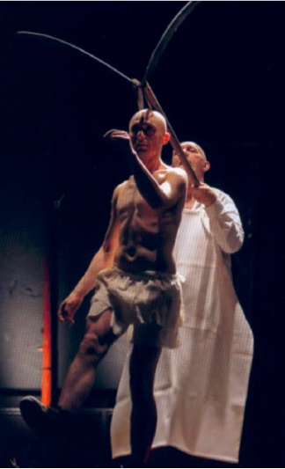
Funeral pomp. Directed by Attila Vidnyánszky. Csokonai Theatre, Debrecen. Photo: András Máthé
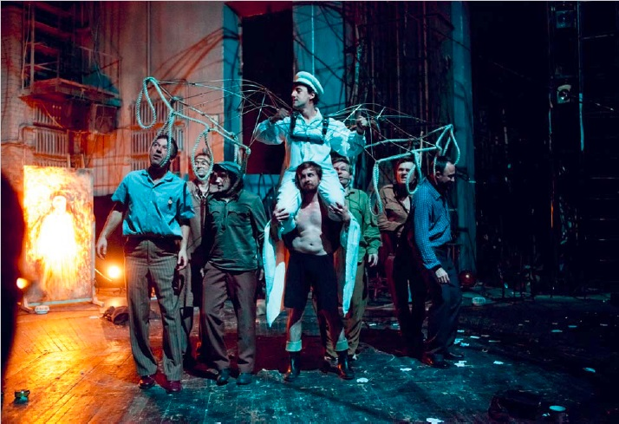
Fabulous Men with Wings. Directed by Attila Vidnyánszky. Csokonai Theatre, Debrecen. Photo: András Máthé
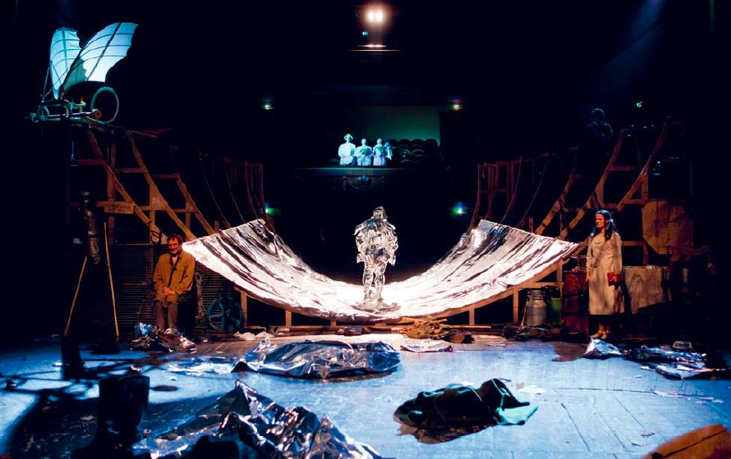
Fabulous Men with Wings. Directed by Attila Vidnyánszky. Csokonai Theatre, Debrecen. Photo: András Máthé
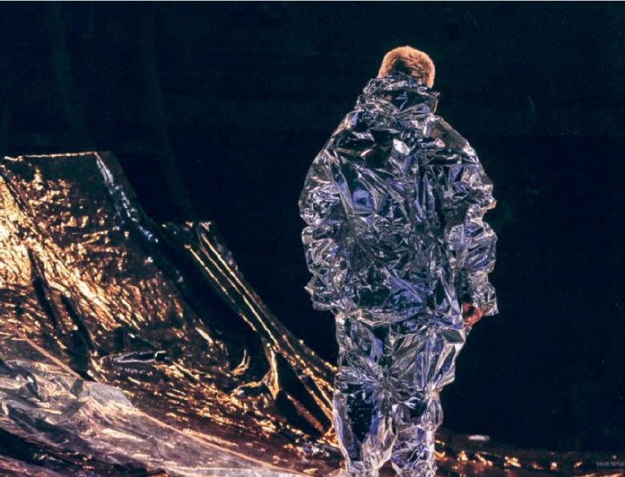
Fabulous Men with Wings. Directed by Attila Vidnyánszky. Csokonai Theatre, Debrecen. Photo: András Máthé
Notes:
1 A közösség művészete [The Art of the Community]. Application draft. Debrecen, 2005, p. 9.
2 A közösség művészete, p. 13.
3 A költői színház [The Poetic Theatre]. Published by Csokonai Theatre, Debrecen, 2013, p. 15.
4 A költői színház, 78.
5 A költői színház, 17.
6 A költői színház, 42.
7 A költői színház, 42.

